git guide - Vit Prechtl

1. Git init

* Creates a new (master) .git file in a repository where Git Bash was launched.
* Or loads the existing directory





1. Git add

* Adds all the files or specific files from the repository into the (master) .git file



1. Git status

* Shows all the files and their changes in the repository that were loaded into .git
* Also shows what branch you are currently on

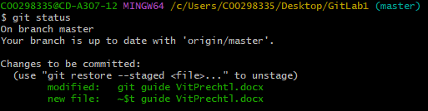

1. Git commit

Creates a new commit in a Git repository (Like an update in a Branch)

1. Git remote

* Remote command sets up a link between the device and online GitHub account

1. Git push

* Sends all the files that are in the repository to GitHub Online repository.

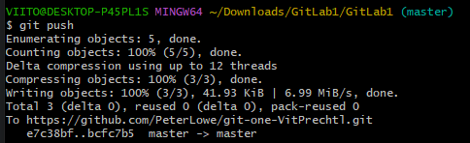

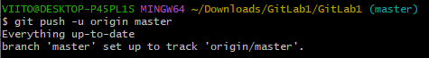

7.Git Branch

- Shows which branch you are currently working on



8.Git Checkout

- Checkout command shows if files uploaded online are up to date, if not a message will pop-up starting with M and then which file is not updated.





9.Git Merge

- Merges multiple branches into the master branch

10.Git Log

- Git log shows all the information about

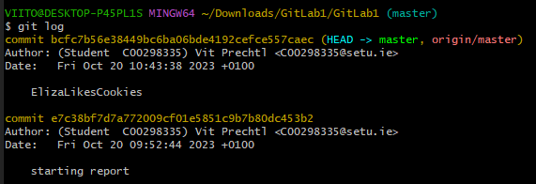

11.Git Clone

- creates a copy of a repository

12.Git Pull

- Git pull is a command that pulls all the data in the local repository to GitHub online repository.

- If there is nothing changed in the files, git will inform you that the online repository is already updated.



13.Git Stash

- saves the working directory

14.Git Rm

- Rm command removes a specific file from a repository and status list

I could not get some screenshots captures for some commands because I was getting not appropriate examples for good explanation. Ex: for Git Remote I just got “origin”.

Apologies